**AWS**

**Cloud Computing Models:**

1. **Infrastructure as a Service(IaaS)**

* Building blocks, Provide access to networking features and storage space

1. **Platform as a Service(PaaS)**

* Removes need of infrastructure (Software and hardware)

1. **Software as a service(SaaS)**

* Runs by Service providers, no need to worry about hardware, storage, softwares,.. etc
* Example: Web based Emails

**Cloud Computing Deployment Models:**

1. **Cloud**

* Build on low level infrastructure and can use high level services

1. **Hybrid**

* Build on cloud and existing resources which are not on cloud

1. **On premises**

* It is legacy for current IT infrastructure
* Sometimes called as the private cloud

**Global Infrastruture**

* AWS cloud infrastructure is built around Regions and Availability zones
* Region is physical location, where have multiple AZ’s
* 42 AZ’s and 16 Regions

**Security and Compliance**

1. **Security**

* Keeps your Data Safe
* Meet Compliance Requirement
* Save Money
* Scale Quickly

1. **Compliance**

**AWS Cloud Computing:**

**Access Services through**

1. **AWS management Console**
2. **Commmand line interface**
3. **Software development kit**

**Compute**

1. **Amazon EC2**

* Web service
* You select your OS Linux or Microsoft

1. **Amazon EC2 Container Service**

* It is a highly scalable, high performance container management services that supports Docker containers
* It is allow you to easily run application on a managed cluster of Amazon EC2 instances.

1. **Amazon EC2 Container Registry**
2. **Amazon Lightsail**
3. **AWS Batch**
4. **AWS Elastic BeanStalk**
5. **AWS Lambda**
6. **Auto Scaling**

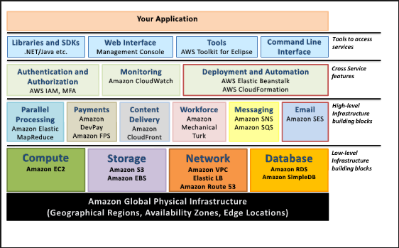

**IAM (Identity and Access Management):**

Consists of the following:

1. Users
2. Groups(A way of groups our users and apply policies to them collectively)
3. Roles
4. Policy documents: Apply them to users or groups. It’s a key value pair in JSON

Example:

{Version”: 2017-4-17”

“Statements”:

{

{“Effects”: “Allow”,

“Action”: “*”,

“Resource”: “*”}

}

}

Star(*) --- wild card

1. IAM is universal, its does not apply to region at this time
2. Root acct is simply created when first setup your AWS account. Root acct has completely admin access.. it’s the only acct has all access by default
3. New users have no permission when created
4. New users are assigned Access Key ID & Secret Access Keys when first created
5. These are not same as the password, you cannot use this Access key and Secret Access key to Login into the console. You can use this to access AWS via the API’s and command line however
6. We get to view this credential once. If you lose them you have to regenerate them. So save them in secure location
7. Always setup multifactor authentication on your root account.. other we will always have to see warning the end of the page
8. We can create and customize and write our own password policy

Example.. 8 length, one Capital, etc..

**EC2 (Elastic Compute Cloud):**

EC2 is a web service that provides resizable compute capacity in the cloud. EC2 reduces the time required to obtain and boot new server instance to minutes, allow us to quickly scale capacity up or down as our computing requirement changes

**EC2 Pricing Options:**

1. On Demand:

Pay as you used by hours, no commitments

1. Reserved:

* Provide us with a capacity reservation, get so much of discounts.. Commitment for 1 yr to 3yr
* Application with steady state and predictable usage
* Upfront payment

1. Spot:

* Enable us to bid whatever price we want for instance capacity
* Stock prices
* Prices changes depend on region , instance
* Application have flexible start and end time
* Pharmaceutical company uses this mostly
* Users with urgent computing needs for large amount of additional capacity

1. Dedicated:

* Physical EC2 server dedicated for our use on our VM
* Useful for regulatory requirement
* Example: US gov and UK govt
* Can be purchase on hourly with physical machines

**EC2 Instance Types:**

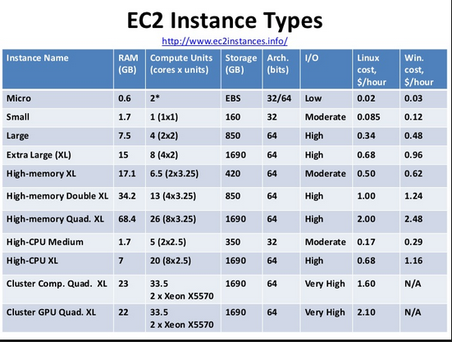

**DIRTMCJ**

* **D for Density**
* **I for IOPS**
* **R for RAM**
* **T for cheap general purpose(Think T2 Micro)**
* **M for main choice for general purpose app**
* **C for compute**
* **G for graphics**

**DR Mc GIFT PX**

* **D for Density**
* **R for RAM**
* **M for main choice for general purpose app**
* **C for compute**
* **G for graphics**
* **I for IOPS**
* **F for FPGA**
* **T for cheap general purpose(Think T2 Micro)**
* **P for graphics (Thinks pics)**
* **X for Extreme memory**